**12. Configure a standard Access Control List (ACL) on a router to permit traffic from a specific IP range. Test connectivity to verify the ACL is working as intended.**

* Added 1 Router, 1 Switch, and 2 PCs.
* Configured Fa0/0 on the Router with IP 192.168.1.1/24 (PC1’s network).
* Configured Fa0/1 on the Router with IP 192.168.2.1/24 (PC2’s network).
* Assigned IP 192.168.1.10/24 to PC1 with Gateway 192.168.1.1.
* Assigned IP 192.168.2.10/24 to PC2 with Gateway 192.168.2.1.
* Created ACL 10 to permit 192.168.1.0/24 and deny all other traffic.
* Applied ACL 10 inbound on Fa0/0.
* Tested from PC1 by pinging 192.168.1.1 → Ping successful.
* Tested from PC2 by pinging 192.168.1.1 → Ping failed.

**Setting Up:**

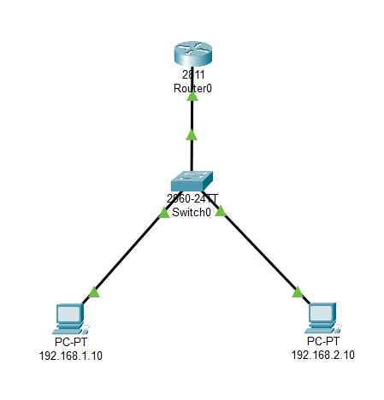

**Configuring Router:**

**Permit 192.168.1.x**

**Deny others**

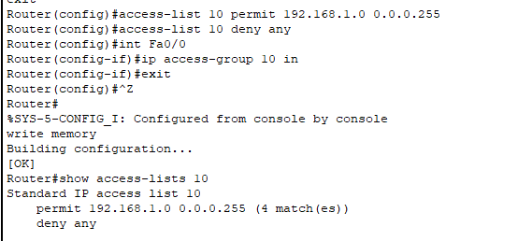

**Pinging the default gateway from PC1: (Succeeds)**

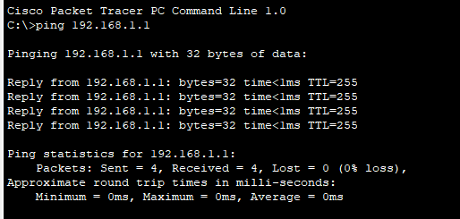

**Pinging the default gateway from PC2: (Fails)**

